The objective of this post is to go into the **inner workings of the package MetaLandSim**, which I developed a few years ago. MetaLandSim’s main objectives are to i) **simulate the occupation** of an habitat network suffering some sort of change (but static landscapes work too); ii) **simulate range expansion** by a species with a metapopulation-like spatial strategy. **Why the emphasis on *metapopulation*?** Well, because these “landscapes” are, in reality graph-like simplifications of a landscape (if you don’t know what a graph is, check [here](https://en.wikipedia.org/wiki/Graph_theory)). You can also check the package [manual](https://cran.r-project.org/web/packages/MetaLandSim/MetaLandSim.pdf) for details.

MetaLandSim simulates the stochastic occupancy of the landscape by a given species using **Stochastic Patch Occupancy Models**, like the **Incidence Function Model**, developed by [Hanski (1994)](https://www.britishecologicalsociety.org/100papers/100_Ecological_Papers/100_Influential_Papers_083.pdf). Being a simulation based upon a stochastic model, it produces slightly different results with each simulation. That’s why we have to repeat each parameter combination many times. Here, considering this is a demonstration, I will run only one simulation.

First, as always, l**oad the package**:

library(MetaLandSim)

Then we should **define the characteristics of the graph-landscape**. Here we are creating a landscape square with a size of 5000×5000 meters, minimum distance between patches  of 20 meters, mean area 0.8 hectares and we are using 300 -which I called dispersal ability- as a threshold to aggregate habitat patches).

Running this function  (if plotG=TRUE) will immediately **plot** the landscape-graph:

rl1 <- rland.graph(mapsize=5000, dist\_m=20, areaM=0.8,

areaSD=0.2, Npatch=180,

disp=300, plotG=TRUE)

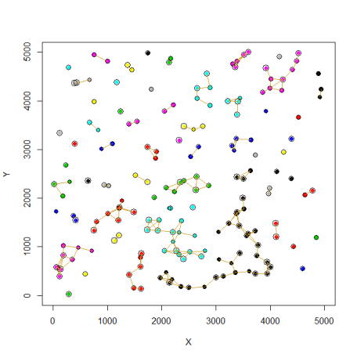

There’s no need to re-**plot** it now, considering that the function rland.graph already did it, but if (for some reason) that’s necessary, here’s how:

plot\_graph(rl1, species=FALSE, links=TRUE)

And now, we can **create the first occupied landscape** (here I selected 10% of the patches to be occupied, those patches in green):

sp1 <- species.graph(rl=rl1, method="number", parm=10, nsew="none", plotG=TRUE)

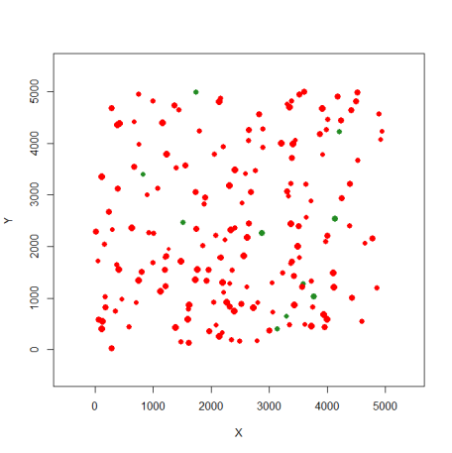

Again, now we don’t need to re-**plot** this landscape. But if that’s necessary use this:

plot\_graph(sp1, species=TRUE, links=FALSE)

Starting with the previously created landscape (rl1) we now create a **list containing this landscape through 100 time steps** (here I did not consider any dynamics -par1=”none”-, check the [manual](https://cran.r-project.org/web/packages/MetaLandSim/MetaLandSim.pdf) for details, so all time steps have the same landscape):

span1 <- span.graph(rl=rl1, span=100, par1="none", par2=NULL,

par3=NULL, par4=NULL, par5=NULL)

Now we need to define the **species parameters**, defining its metapopulational dynamics.

Metalandsim provides **Bayesian-based functions** to derive these parameters, based upon the work of [Benjamin Risk](https://www.researchgate.net/profile/Benjamin_Risk) in this [paper](https://nature.berkeley.edu/beislab/BeissingerLab/publications/Risk_etal_2011_Ecology.pdf) (his original functions are [here](http://www.esapubs.org/archive/ecol/E092/040/)).

Benjamin adapted his functions to be included in this package. Later, we collaborated, and used this approach in our 2017 [paper](https://www.sciencedirect.com/science/article/pii/S0304380016307669#sec0070) (we provided the R scripts as supplementary information, these can be downloaded from the paper’s website). This is the **recommended** procedure, but the package has another function ([parameter.estimate](https://rdrr.io/cran/MetaLandSim/man/parameter.estimate.html" \t "_blank)). It provides some other approaches (however *I don’t recommend it*). It is useful sometimes, for didactic reasons, because it’s *way* simpler (and that is why it was not yet deprecated).

Here I’m only going to **create the parameter data frame**, assuming these were previously estimated.

param1 <- create.parameter.df(alpha=0.0045, x=0.5, y=2, e=0.04)

For details on what does each of these parameters means go [here](https://rdrr.io/cran/MetaLandSim/man/param1.html).

And, finally, **simulate the species occupation** (considering the parameters just defined) through the time steps:

sim1 <- simulate\_graph(rl=sp1,

rlist=span1,

simulate.start=FALSE,

method=NULL,

parm=NULL,

nsew="none",

succ = "none",

param\_df=param1,

kern="op1",

conn="op1",

colnz="op1",

ext="op1",

beta1=NULL,

b=1,

c1=NULL,

c2=NULL,

z=NULL,

R=NULL

)

No, just to see what with the species occupation thorough time, we can **plot a few of the time steps** (1, 20, 40, 60, 80 and 100):

par(mfrow=c(2,3))#we are going to 6 time steps

#First landscape

plotL.graph(rl=sp1, rlist=sim1, #time step 1

nr=1, species=TRUE, links=FALSE)

plotL.graph(rl=sp1, rlist=sim1, #time step 20

nr=20, species=TRUE, links=FALSE)

plotL.graph(rl=sp1, rlist=sim1, #time step 40

nr=40, species=TRUE, links=FALSE)

plotL.graph(rl=sp1, rlist=sim1, #time step 60

nr=60, species=TRUE, links=FALSE)

plotL.graph(rl=sp1, rlist=sim1, #time step 80

nr=80, species=TRUE, links=FALSE)

plotL.graph(rl=sp1, rlist=sim1, #time step 100

nr=100, species=TRUE, links=FALSE)

The **species gradually expands** from the initial occupied habitat patches (the green patches on the top left landscape-graph):

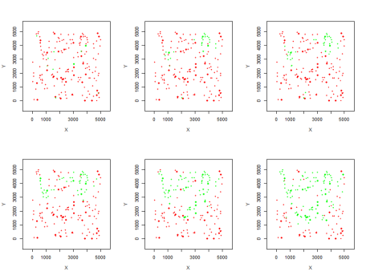

Finally, just a **few reminders**:

* This post was only to **demonstrate** the basic reasoning behind these simulations;
* The **species parameters** should be carefully estimated (see the Bayesian approach);
* MetaLandSim’s simulations should be **repeated many times** (to allow the results to stabilize). This one-run simulation was an example (for more on this, check the [iterate.graph](https://www.rdocumentation.org/packages/MetaLandSim/versions/1.0.4/topics/iterate.graph?tap_a=5644-dce66f&tap_s=10907-287229) function).